As a priority, this site and funnel is going to be built on the following principles. All decisions will first be filtered through the following requirements:  
   
**Filter # 1 Quality in code**. The days of the server caching pages and them reverting, and things getting screwed up randomly are over.   
We should not do any “This will work for now” code or design. We must do it right from the beginning. Nothing half assed, or cheap. We put in the work and make the code solid from beginning to end.   
  
**Filter # 2 Simplicity** – The fewer steps for us, the better. The fewer steps for the customer, the better.   
The fewer steps for our code, the better.  
Less code, less plugins, less dependence on SAAS. If we can live without them, we will.   
Simplicity in tagging. Simplicity in the number of segments we create (men/women cutting/bulking/performance).   
Everything from our content, to our blogs, to our server, to our email automation must be simplified and hyper efficient.  
The passwords we need to run this site, the better.  
 **Filter # 3 Site speed** – We must always make decisions that increase site speed, or at a minimum, don’t distract from it.   
  
**Filter # 4 SEO** - Every single page & URL we create will be built, redesigned or rewritten for SEO optimization.   
- If it negatively impacts SEO, we do not do it.   
- If there is a way to have it impact SEO for the better, we do it that way.  
  
**Filter # 5 Plugins** - Every plugin we use must play well with all other plugins and SAAS code.  
If one conflicts with another, we cannot use it.  
-We should not make any custom code changes to plugins. If they don’t suit our needs, we skip them  
 **Filter #6 Data for analytics & split testing** – We need to make sure that every page we build, whether it is in wordpress or click funnels, is built to give us quality data. We need to be able to track every email, every page, every of the customer journey client introduction (search, email, landing page) to the order page, upsells, downsells all the way to the thank you page, regardless if it is on WP or CF.  
  
  
**Filter # 7 W3c compliant** – Yeah, I know it is an old standard, but it is important for SEO.  
  
**Getting started:**  
  
**Wordpress Plugins**   
First, we need to kill all obsolete and legacy plugins.   
- If we don’t use it, we don’t transfer it.  
- If it does not pass the above filters, we don’t transfer it.  
  
Second, we need to look at the plugins we currently use and make sure they are the best options for the new site, based on the filters I posted above.   
- If no, we need to replace them with better plugins that pass our filter test.  
- If yes, we need to update them and make sure they play well with one another.  
  
We should only use plugins that we absolutely must have.  
When there is a professional or upgraded premium version available we should get it to make sure we have support from the coder and to support them as well.  
  
**Here are a few others plugins to consider:**  
CF/WP only if we need it - <https://wordpress.org/plugins/clickfunnels/>   
Commenting plugins like Disqus? Should we use this at all?  
  
**Here is some SAAS that we will use**  
Funnelytics.com – This is a no brainer. Must be added  
Upviral.com – We need to look in to this and use when we can.  
Split testing Plug in - Nelio for WP <https://neliosoftware.com/testing/>  
Click Funnels Backpack – Affiliate software  
  
**Click Funnels vs Wordpress**  
Where we can use click funnels pages we will  
All order/cart pages will be created (and split tested) on click funnels.   
  
Split test a video at top of every sales page similar to [www.digitalmarketer.com/lab-basic](http://www.digitalmarketer.com/lab-basic)  
  
**Calculator configuration**:  
There will be 3 delivery options users can select from at the end of the calculator to get their macros:  
**Macros only  
Email me my macros & 5 day video course  
Upgrade to the Advanced Macro Report ($19)  
  
Option 1** – MACROS ONLY PLEASE

Forwards to CF sales page with macros and light copy (above the fold) Pie chart + a bit more info.  
Video at top of page will add value and encourage them to sign up CTA  
CTA Split test 1 – Sells them on option 2 – Email optin for macro profile & free 5-day video course  
CTA Split test 2- Upgrade to $19 Blueprint/advanced report (which is same as calc option 3)

**Option 2** – EMAIL me my Macro Profile with free 5-day video course

Forwards to sales page like:

<https://www.123test.com/disc-personality-test/id=fU7YVBX0KPU4O23&version=?fbclid=IwAR0lx1BXTm3hmMpUUamUPXi5NKi0zAGS5pqyohJyFugVolqbyEuK__Rhy_8>  
  
Video at top of page, macros and content under.  
Video will sell them on signing up to macro profile and free 5-day video course (email optin)

Macro profile data will retained as a user ID (macro ID) which will be added to a URL that when visited, will display all dynamic input for the macros, macro profile or macro report, similar to this URL:  
  
<https://tdeecalculator.net/result.php?s=imperial&g=male&age=44&lbs=222&in=69&act=1.2&f=1>  
Only, we will make the user ID abstract and not distinguishable by the user.  
They can share this URL and others can see the same page so they can share it with friends, social media or trainer.  
  
This way, users can email the URL to friends or post to social media and everyone can see their macro profile. This also prevents us from having to add/store every single user to the DB.  
  
We will also pass this URL on to Clickfunnels so we can inject it in to the membership site, where users will have access to their macro profile and free 5 day video course.  
  
The bottom section of their macro profile will be short sales copy with CTA that sells the advanced macro report which is split tested for pricing  
  
**Option 3 -** Advanced macro report with complete macro strategy $$$  
This options forwards to a click funnels order/cart page   
Cart split test 1 forwards to click funnels cart for $x price based on previous page  
Cart split test 2 forwards to click funnels cart for $xx price based on previous page  
  
Order bump will be inexpensive $17-27 product to get them to say YES one more time.  
  
Once payment is complete, user will go through CF OTO upsell/downsell pages then thank you page:  
-Upsell #1 – Video Course – Lifetime membership for $97  
-Downsell #1 -Video Course monthly subscription $7  
  
-Upsell #2 – Legacy Subscription (annual) – 1 year $197   
-Downsell #2 – Legacy Membership (monthly) $47  
  
-Final Downsell if 2 no’s $297 lifetime membership plus macro Vault & all ebooks.  
  
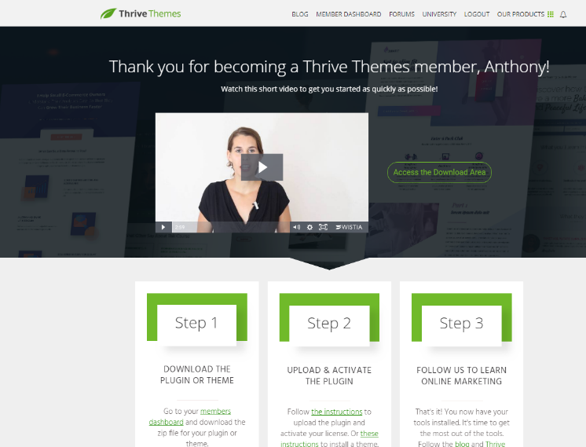  
  
Step 1. Click here to to access your Macro Master Class Video Course  
Step 2. Click here to join the IIFYM Client Only Support Group on FB  
Step 3. Click here to access your Advanced Macro Report (leads back to our WP site, with report displayed on the page)  
  
Advanced macro report will have CTA at the bottom that sells them on core product.  
  
Delivery of free macro results will be direct via WP page  
Delivery of macro profile will be direct via CF page  
Delivery of macro report will be direct on CF page

**Macro Profile page will display the following information (Macro profile will display much less)**  
Short explanation of what macros are and what role the play  
Review of their data input  
Review and explanation of Dynamic considerations (vegan, diabetic, menopause, pregnant, soma type)  
How we calculated their macros  
Display coefficient with explanation  
Display BMI and why it doesn’t matter  
Display their BMR, what it means and how we use it   
Display their TDEE calories, what it means and how we calculate it  
Their Cutting macros with coefficient & pie chart  
Their TDEE macros with coefficient & pie chart  
Their Bulking macros with coefficient & pie chart   
Macro Slider to adjust macros & pie chart without changing calories or coefficient  
Address their Dynamic Considerations  
Address non insurance covered dynamic considerations (pregnant, nursing)  
Slider to display how macros change as energy/exercise increases   
**Advanced Macro Report will include everything from above, plus:**  
  
  
  
Specific (blueprint) instructions on how to get started  
Specific protocol based on their goals.  
Specific protocol on how to adjust when stalled  
Perfect supplement list  
Perfect foods list  
Keto Macros (pie chart)  
Vegan macros (pie chart)   
Bodybuilder Macros (pie chart)   
Carb cycling instructions  
Example meal plan   
Refeed macros (pie chart)  
Refeed instructions   
Reverse Diet instructions

**Core offer will be as follows:**  
**1 bundle only (BP, MA & Legacy)**  
-$37 /mo (billed monthly) cancel any time  
-$20 /mo (billed every 12 months @ $180 - includes all ebooks)  
-$297 lifetime access (includes access to the Macro Vault)